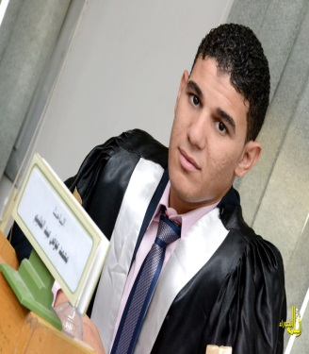Assiut University  
Faculty of Physical Education  
Department of Curriculum and teaching of Physical Education  
  
      
Name: Mohamed Awad Abdel Halim  
  
Date of Birth: 05/01/1990 Nationality: Egyptian  
Marital status: Single Religion: Muslim  
E-mail: moh.awad2011@yahoo.com  
  
E-academic Muhamm.awad@phyedu.au.edu.eg  
Tel: 01067079473  
  
  
  
Position  
:  
Assistant Lecturer, Department of Curriculum and teaching of Physical Education  
Organization It: Faculty of Physical Education. Assiut University  
Department: Department of Curriculum and teaching of Physical Education  
Major: Physical Education  
Specialization: teaching handball  
  
  
  
  
  
  
  
  
Name of qualification obtained Specialization date of acquisition  
- Bachelor of Physical Education College of Physical Education - Assiut University Handball 2011  
- Master of Physical Education College of Physical Education - Assiut University Handball 2014  
  
  
  
  
- Teaching Assistant, Department of Curriculum and teaching of Physical Education. Assiut University. Handball allocated as of 2011.  
- Assistant Lecturer, curricula and teaching Physical Education Department. Assiut University. Handball allocated as of 2014.  
  
  
  
  
- Handball player Sohag region in the period from 2000 until 2007.  
- Team handball coach Girls College of Education sports Assiut University.  
- Ambassador of the Information Technology Unit, Department of Curriculum and teaching of Physical Education College of Physical Education Assiut University.  
- Supervising the camps Scout first aid in the period of 2011 to 2015 m.  
- Ruling handball area Assiut.  
- Member of the steering committee and governance within the Quality Committee at the Faculty of Physical Education Assiut University  
- Participated in many student conferences.  
  
  
  
  
- Orascom cycle of human development.  
- English course at the Faculty of Literature Assiut University.  
- Proficiency in English language course at the Faculty of Arts, Assiut University (ELPT)  
- The capacity of faculty members at the University of Assiut development cycles.  
- Coors BY LAWS N & CONTROL AFFAIRS of the training center on information and communication technology (ICTB)  
- Holds a training course in the statistical software (SPSS) of the Training Centre for Information and Communication Technology (ICTB)  
- Holds a training program (TOP PLAY & TOP SPORT) of the British Council  
  
  
  
- Holds a program many of the certificates of appreciation for scientific excellence and active participation in the activities and student conferences.